{{TODAY_LONG}}

SENT VIA FIRST CLASS MAIL, FASCIMILE AND EMAIL
{{insurance2.insurer.name}}
Attn: {{insurance2.adjuster.name}}
{{insurance2.adjuster.address1line1}}
{{insurance2.adjuster.address1line2}}
{{insurance2.adjuster.address1city}}, {{insurance2.adjuster.address1state}} {{insurance2.adjuster.address1zip}}
F: {{insurance2.adjuster.fax1}}
E: {{insurance2.adjuster.email1}}

Re: Our Client(s): {{fullname}},__________ ,and

Your Insured: {{insurance2.insured.name}}
Date of Accident: {{intake.incidentDate| longDate}}
Claim Number: {{insurance2.claimnumber}}
Policy Number: {{insurance2.policynumber}}

FOR SETTLEMENT PURPOSES ONLY
WARNING!!! This is your final opportunity to resolve this matter before the attached complaint is served on your insured. Please immediately tender your insured’s policy limits to our client so we are not forced to seek an excess verdict against your insured.
Dear Mr./Ms. {{insurance2.adjuster.lastname}}:
In response to your most recent offer to settle of $160,000, please allow this letter to serve as confirmation of our client’s declination. Liability against your insured, who failed to stop in time and crashed into our client’s car, is clear. Edel was rushed to the hospital, conscious, via ambulance. The police were called, and your insured was cited. Causation is also clearly demonstrated by the fact that our client’s injuries were seriously aggravated by the crash.
As a reminder, {{firstname}} suffered from the following injuries:
University Medical Center – DOS 6/21/2017
Client was immediately brought in conscious by Medicwest Ambulance after being in an accident on 6/21/2017. Client immediately complained of low back pain, mid back pain, and abdominal pain.

Spring Valley Hospital: DOS 6/23/2017
Mr/Ms. {{lastname}} stated that he/she initially presented with abdominal pain. However, he refused their service and was not treated. He then transferred and was treated at Valley Hospital Medical Center.
Valley Hospital Medical Center: DOS 6/23-24/2017
Came in with constant abdominal pain that started on 6/21/2017 when he was in an MVA. The pain was moderate and was characterized as sharp. The client stated that he had an umbilical hernia for years now but was recently involved in an MVA, which caused the pain to worsen more then it normally was.

Impression:
- Abdominal pain
- Umbilical hernia
Edel was given Norco 5mg – 235mg tablet for pain and given educational materials regarding hernias. Mr. Sanchez-Millan was discharged the following day and was instructed to immediately seek medical help if the pain worsened.
Apache Health Center: DOS – 6/21/2017 – 9/18/2017
Edel presented to Apache Health center where Dr. Jordan Miamoto examined him for treatment of his symptoms. Edel stated that he was taken to UMC for immediate treatment in an ambulance. X-Rays were taken at the hospital to rule out any breaks or fractures. Edel presented himself the same day with chief complaints of neck pain, mid back pain, lower back pain, and headaches. Edel rated the intensity of his pain from 8-9 out of 10, where 10 was the most painful. He characterized his pain as sharp, tingling, and aching.
Diagnosis:
- Sprain of ligaments of cervical spine, subsequent encounter
- Sprain of ligaments of thoracis spine, subsequent encounter
- Sprain of ligaments of lumbar spine, subsequent encounter,
- Nervousness
- Headache
- Acute pain due to trauma
- Other biomechanical lesions of cervical region
- Other biomechanical lesions of thoracic region
- Other biomechanical lesions of lumbar region
- Insufficient sleep syndrome
- Radiculopathy, cervical region
Radiculopathy, thoracic region
- Radiculopathy, lumbar region
Client was scheduled to visit 3 times a week for 4 weeks. During that time, the client was given treatments such as chiropractic adjustment, electric muscle stimulation, massage therapy, manual therapy, mechanical traction, and ultrasound.
Velazquez Pain Relief Center: DOS: 6/22/2017 to 12/13/2017
Edel was also referred to pain management with Dr. Luis Velazquez. Edel communicated continuing pain of his cervical spine, lumbar spine, and abdominal pain. It was noted that Edel had a pre-existing umbilical hernia which was aggravated by the crash. As a result he was now experiencing severe abdominal pain. The cervical spine pain radiated to the head, bilateral trapezius, parascapular region. Edel’s neck was tender to the touch, and limited his cervical range of motion. The pain at his lower back was axial, was also tender to the touch and limited his range of motion. He described his pain as sharp and aching, and rated it at 10/10.
Assessments:
- Acute abdominal pain
- Traumatic spondylopathy of lumbar region
- Traumatic spondylopathy of cervical region
- Strain of muscle, fascia and tendon of lower back, sequela
- Strain of muscle, fascia and tendon at neck level, sequela
- Headache, cervicogenic
- Myalgia
- Abdominal hernia with obstruction without gangrene, recurrence not specified, unspecified hernia type.
- Cervical Radiculitis
- Lumbar Radiculopathy
MRIs revealing significant findings, prompted the following procedures to be performed:
- Procedure: Lumbar Transforaminal Epidural Steroid Injections, Fluoroscopic Guidance under Anesthesia (bilateral L5-S1 and S1) at Red Rock Surgery Center by Dr. Luis Velazquez. Sedation by Dr. My Linh Jennifer Tran. Dates of Service - 7/26/2017, 11/08/2017, 11/29/2017.

- Procedure: Cervical Epidural Steroid Injection (right sided) at Red Rock Surgery Center by Dr. Luis Velazquez. Sedation by Dr. My Linh Jennifer Tran. Dates of Service - 7/26/2017, 11/01/2017.

Valley Hospital Medical Center: DOS – 6/22/2017
- Procedure: CT Abdominal Pelvis, without Contrast.

Impression: No Acute intra-abdominal process.

- Procedure: CT Abdominal Pelvis, with Contrast.
Impression:

- Diffuse hepatic steatosis noted
- No abnormalities identified to explain patient’s abdominal pain.

Pueblo Medical Imaging: DOS – 7/7/2017
- Procedure: MRI of the Lumbar Spine, without Contrast
Interpretation:
- Evidence for lumbar strain
- Bilateral spondylolysis L5-S1 with associated grade 1, 3 to 4 mm spondylolisthesis
- Bilateral posterior facet joint synovitis L3-L4 and L4-L5
- Annual tears L5-S1 intervertebral disc
- Posterior disc bulge L4-L5 (1 to 2mm)
- Central and bilateral posterolateral disc protrusion L5-S1 (4mm)
- Bilateral lateral recess stenosis L5-S1
- Moderate bilateral neural foraminal narrowing L5-S1

- Procedure: MRI C-Spine, without Contrast

Interpretation:
- Evidence for cervical strain
- Bone Contusion C5 vertebral body
- Posterior disc bulge C4-C5 (1 to 2 mm)
- Posterior disc protrusion C2-C3 (3mm)
- Posterior disc protrusion C3 to C4 (2 to 3mm)
- Posterior disc protrusion C5 to C6 (3mm)
- Mild right-sided neural foraminal narrowing C5-C6
Primary Care Physicians: DOS – 8/11/2017

Edel was seen by Dr. Humberto Rodriguez, Jr. for clearance to undergo a surgical procedure at Seven Hills Surgical Center. He underwent a series of tests and the procedure was cleared.
Southern Nevada Surgery Specialist: DOS- 8/16/2017
Edel presented with a longstanding umbilical hernia, which he believed the pain was exacerbated after being in an accident on 6/21/2017. Before consult, the client had had a significant workup and was found to have a fatty liver, but no other significant findings besides the hernia. Client had already had a previous umbilical hernia repair with placement mesh.
On August 16, 2017 underwent the following procedure under anesthesia: Umbilical Hernia repair with Placement of Mesh at Seven Hills Surgery Center.
Taking {{firstname}}’s injuries and damages into consideration, your offer is highly inadequate in comparison to other verdicts and settlements for similar injuries. Below are examples of other verdicts:

- Austin vs. Contrast Lighting Services Inc- Verdict - $650,000.00 - MRI of the cervical spine showed C5-C6 central disc bulge resulting from a car wreck.
- Toney vs. Magana- Verdict - $500,000.00 a lumbar MRI was the most significant evidence for a disc bulge at C4-C5, which was the basis for the verdict.

Those cases both involved Plaintiffs that suffered from only one level of disc injuries. Unlike the above cases, {{firstname}} has injuries at multiple disc levels, his/her damages are therefore greater and would foreseeable lead to larger verdicts than those seen above. Furthermore, it is clearly documented that his prior hernia injury was seriously aggravated by this crash. This aggravation prompted Edel to go to three different hospitals and seek therapy from multiple providers before he finally received a final Hernia Repair Surgery.

Our client(s) is/are understandably upset at this whole ordeal and would like to put this behind him and move on with his life. This is a case where the damages will far exceed the current offers. We will file suit against your insured and obtain a judgment in excess of what we are demanding and potentially even pop the policy limits. A jury would not hesitate to award money damages in the $750,000.00 to $1,250,000 range based on the above facts. We do not believe a jury will think your insured’s failure to maintain due care and stop in time, impacting our client’s vehicle was a small matter.

Furthermore, they will NOT think that failing to compensate {{firstname}} for his/her serious pain and suffering and demonstrable injuries is okay and will award a high amount of compensatory damages here. The entire story will be heard by the jury.

We demand $195,000 which our client(s) has expressly authorized me to accept within the next seven days. We are extending you until 5:00 p.m. June 12 to accept our offer.
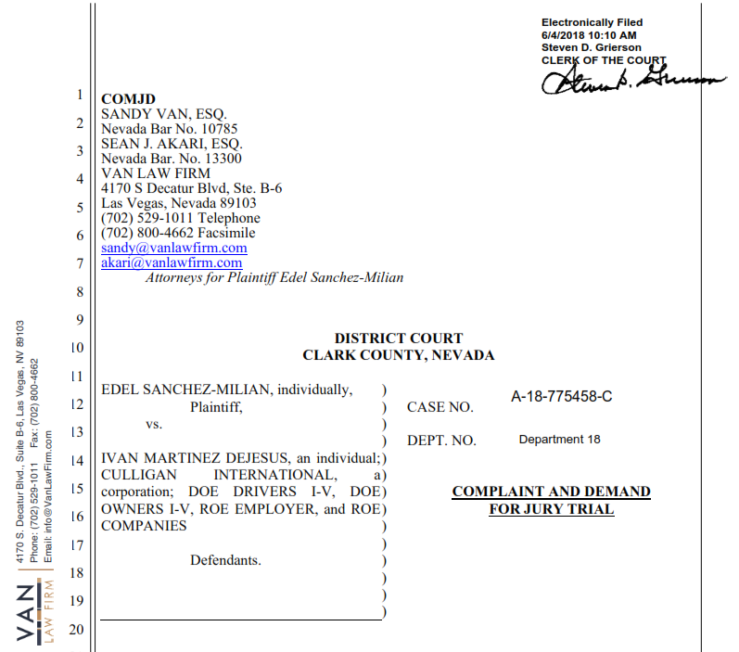
Should {{insurance2.insurer.name}} not accept our offer to settle for our offer by the above deadline, the offer to accept the limit is automatically revoked. We will serve the attached complaint and proceed to obtain a jury verdict as indicated, and we will seek to hold your insured responsible for the full measure of our client’s damages and losses.
Please forward a copy of this letter to your client; as you have a duty to send him this letter. Let us resolve this case now without further delay and expense and not subject your client to any excess liability. Please note that this correspondence and its content are inadmissible in court pursuant to ER 408. I look forward to hearing from you soon.

Very Truly Yours,

Andrew Stikovac, ESQ.
Gold Medal Injury Law
AS/______

